**SEARCH ENGINE OPTIMAZATION (SEO)**

**BY**

**TUKUR ABDULLAHI MOHAMMED**

**ST/CS/ND/18/175**

**BEING A SEMINAR PAPER**

**PRESENTED TO THE DEPARTMENT OF COMPUTER SCIENCE**

**SCHOOL OF SCIENCE AND TECHNOLOGY, FEDERAL POLYTECHNIC, MUBI ADAMAWA STATE, NIGERIA**

**IN PARTIAL FULFILMENT OF THE COURSE REQUIREMENTS FOR THE AWARD OF NATIONAL DIPLOMA (ND) IN COMPUTER SCIENCE**

**FEBRUARY, 2021**

**ABSTRACT**

***Whenever you enter a query in a search engine and hit 'enter' you get a list of web results that contain that query term. Users normally tend to visit websites that are at the top of this list as they perceive those to be more relevant to the query. If you have ever wondered why some of these websites rank better than the others then you must know that it is because of a powerful web marketing technique called Search Engine Optimization (SEO). SEO is a technique which helps search engines find and rank your site higher than the millions of other sites in response to a search query.***

**INTRODUCTION**

According to Erik (2010) whenever you enter a query in a search engine and hit 'enter' you get a list of web results that contain that query term, Users normally tend to visit websites that are at the top of this list as they perceive those to be more relevant to the query. If you have ever wondered why some of these websites rank better than the others then you must know that it is because of a powerful web marketing technique called **Search Engine Optimization (SEO)**.

SEO is a technique which helps search engines find and rank your site higher than the millions of other sites in response to a search query. SEO thus helps you get traffic from search engines. This SEO tutorial covers all the necessary information you need to know about Search Engine Optimization - what is it, how does it work and differences in the ranking criteria of major search engines.

**Brief History of SEO**

**1995** - Yahoo Launches its Web Directory

**1998** – Google Launches, DMOZ launches this same year

**2000** – Yahoo Drops AltaVista, Uses Google’s Algorithm instead

**2001** – Page Rank is revealed to users through the toolbar

**2005** – No Follow Tag Introduced

**2009** – Google Introduces Caffeine Algorithm, a major shift in SEO.

**2009** – Bing and Yahoo Merge

**2011** – Panda Algorithm Update. A major step in the history of SEO

**April 24th 2012** – Penguin Algorithm Update

**September 27th 2012** – EMD Update (Exact Match Domain)

**October 4th 2012** – 65 Pack Rollout

**SEARCH ENGINE BASICS**

According to Danny Sullivan (June 14, 2004) state SEO as the process of improving your site to increase its visibility for relevant search. SEO has some basics these are:

**Processing queries:** When a request for information comes into the search engine, the engine retrieves from its index the entire document that match the query.

**Ranking results:** Once the search engine has determined which results are a match for the query, the engine's algorithm (a mathematical equation commonly used for sorting) runs calculations on each of the results to determine which is most relevant to the given query.

**IMPORTANT OF SEO**

**1.** **Brand awareness** – A web site having a high ranking means more people see the name of the company and become familiar with the company and its products, even if they haven’t made a purchase.

**2.** **Targeted traffic** – Search engine optimization brings paying customers to your Door step. The customers that SEO services bring you are long for your products/services as they have entered your websites keywords/phrases into the search engines.

3 **Your competitors** – Keeping ahead of your competition in the organic search results can help boost the perceived position of your company in your marketplace.

**HOW DOES SEO WORKS**

According to Brian Pinkerton (May 7, 2007) Search engines, such as Google, Yahoo!, and Bing, scour the World Wide Web. Their automated "robots" (also called "spiders") move from page to page and site to site by following links. Along the way the read the code for the pages they visit. The information from the page code is incorporated into the search engine's vast knowledge base.

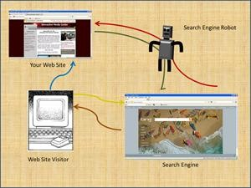

Figure 1: Search engine optimization process

When a visitor to a search engine enters a term or phrase into the search box the term or phrase is compared to the information in the engine's knowledge base. The results that are returned (called "organic results") are listed in order of how well they match the term or phrase that was used to initiate the search. the comparison is accomplished by algorithms. The specifics of the algorithms are closely guarded secrets of the search engines. Apparently, the algorithms vary from search engine to search engine. However, the techniques that we discuss here are applicable to all the engines.

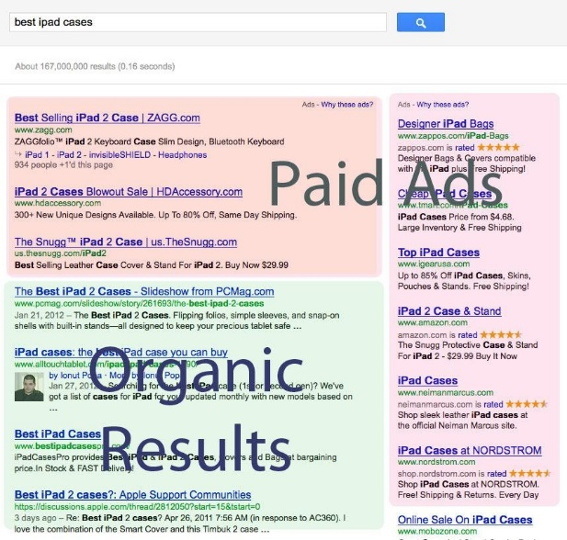

Figure :2 Organic Result and Ads

Jansen B.J (2012) the closer the Web site matches the search term, as determined by the algorithm, the higher it will appear in the list of organic results. The goal of search engine optimization is to help the Web site and its pages rank as high as possible in these organic results.

It is important to remember that search engines sell advertising on their sites. Which ads appear on the results page are also determined by sophisticated algorithms, and are based on the comparisons with the search terms. Your organic result placement will compete with these ads. The better your search engine optimization, the better your placement in the overall results.

**ADVANTAGE OF SEO**

**1**.it’s cost-effective. You don't have to pay the search engine to be "advertised". At this point in time is when you have to pay for almost everything; it's good to know that there are still some things which are free. The best part is that you can use this to your benefits, such as the simulative effect of the sale of your business. Ortiz-Cordova (2012).

**2**. If well ranked, has your company greater chance at becoming visible around the world, while you stay at home. Internet is an effective marketing tool. It is actually the marketplace itself with numerous potential clienteles. However, there is no guarantee that your business will boom immediately but it sure will, little by little Ortiz-Cordova (2012).

**3**. Once your website gets a good place, you somehow your reputation as one of the best. This implies that somehow you are properly valued in the SEO community. In reality, which ranked first in their field are perceived to be really good. They are even considered to be one of the largest. Same thing in the virtual world. If you are the highest rank, people will think that the product that you sell is a must have Ortiz-Cordova (2012).

**4**. Need the money for search engine optimization is established, regardless of the number of hits you get. This saves you some money. Plus, you don't get confused with the accounting part. Another thing, you don't worry about the money that you need to shell out for the case you a bulk of hits.

**DISADVANTAGES OF SEO**

According to Jansen B.J (2015)

**1**. Your position in the search engine is unpredictable. Everything depends on the algorithm. As a result, you know not when the return of the investment will happen. You don't have the total control over everything, even if you have your website; you maintain that you and the owner of the company.

**2**. This is time consuming. It takes a long time before you see your standing improve a notch. Sometimes you have to wait for months or even a year to be in the spotlight.

You might ask yourself, "How can my business flourish?"

**3**. Participants can make use of the black hat tactics. These unfair practices hinder the tree of your company. You control not about other people's heads. They can choose for unethical strategies and you, your company could affect credibility and negative.

**4**. It may mean the end of it all for entrepreneurs whose website are located on the last few pages of the search engine.

**CONCLUSION**

While nobody can guarantee top level positioning in search engine organic results,

Proper search engine optimization can help. Because the search engines, such as Google, Yahoo!, and Bing, are so important today it is necessary to make each page in a Web site conform to the principles of good SEO as much as possible

To do this it is necessary to: Understand the basics of how search engines rate sites

Use proper keywords and phrases throughout the Web site Avoid giving the appearance of spamming the search engines Write all text for real people, not just for search engines Use well-formed alternate attributes on image Make sure that the necessary meta tags (and title tag) are installed in the head of each Web page Have good incoming links to establish popularity Make sure the Web site is regularly updated so that the content is fresh

**Recommendation**

**Target audience:** Your target audience is a defined set of people who you are marketing your product to. Traditionally, defining a target audience involves determining their **age**, sex, geographic locations, and especially their needs (aka pain points)

* **Keyword choices:** Think like a customer. Identify your target audience and put yourself into the shoes of a customer when you create your initial list of **keywords**. ...
* Study the competition. ...
* Understand the long tail **keyword**. ...
* Use **keyword** research tools. ...
* Analyze the result

**REFERNCE**

Beel, J. Gipp, B. and Wilde, E. (2010). [Academic Search Engine Optimization (ASEO): Optimizing Scholarly Literature for Google Scholar and Co](https://www.sciplore.org/publications/2010-ASEO--preprint.pdf). *Journal of Scholarly Publishing.* pp. 176–190.

Cordova, A. and Jansen, B. (2012) [Classifying Web Search Queries in Order to Identify High Revenue Generating Customers](https://faculty.ist.psu.edu/jjansen/academic/jansen_high_revenue_customers_2012.pdf). *Journal of the American Society for Information Sciences and Technology. 63(7),* 1426 – 1441.

 Brian, P. (2014). [*Finding What People Want*: Experiences with the WebCrawler](http://www.thinkpink.com/bp/Thesis/Thesis.pdf). McGraw Hill.

Danny, S. (2004). ["Who Invented the Term. "Search Engine Optimization"?"](https://web.archive.org/web/20100423051708/http:/forums.searchenginewatch.com/showpost.php?p=2119) Retrieved February 3, 2021 from <https://www.thesnuggs.com/iPAD>